Reg. No. CODE: COREZOO
PH. D COURSEWORK EXAMINATION, MAY 2023
SUBJECT: LIFE SCIENCES (ZOOLOGY)
CORE PAPER
Time: 03 hours Maximum Marks: 50
Instructions: Answer all questions

- Examine the data and then answer the questions after the graph. Each sub question carries 2 marks (10 marks)
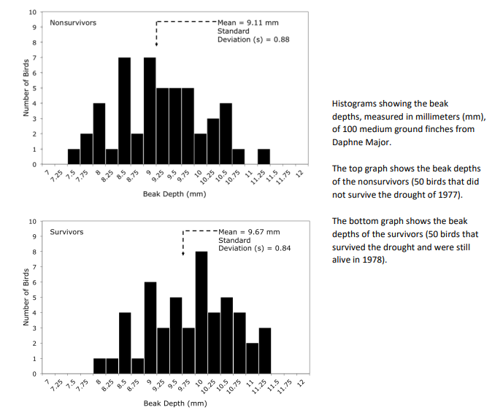
- Observe the shapes of the graphs. It may help to draw a line connecting the tops of the black bars.
  - Describe the overall shape of each graph. (1 marks)
  - What do the shapes of the graphs indicate about the distribution of beak depths in these two groups of birds (1 marks)
- Compare and contrast the distributions of beak depths for the survivors and non-survivors. For each distribution, include the range of the data and the most common measurements. (2 marks)
- Propose a biological hypothesis to explain the differences in the distribution of beak depths for the survivors and non-survivors. (2 marks)
- How do the means and standard deviations compare between the groups? (2marks)
- If the standard deviations of the two groups were very different, what would you conclude about the groups? (2 marks)

- In a hypothetical population consisting of 100 moths, 81 individuals have peppered morphology. Their genotype is dd. The other 19 individuals are dark colored and have either genotype DD or genotype Dd. Find p and q for this population and calculate the frequency of heterozygous genotypes in the population. (5 Marks)

- Answer the following questions after reading the paragraph below. Each sub question carries 2 marks (10 marks)
Over the course of evolutionary time, humans have established populations in a variety of extreme environments, including mountains, deserts, and polar regions. The conditions in these environments may lead to natural selection for certain traits. One example of natural selection in humans may come from the Bajau people of Southeast Asia, who are sometimes called Sea Nomads. For over 1,000 years, the Bajau have lived off the seas, traditionally gathering food and other resources through freediving (diving that requires holding your breath underwater instead of using an oxygen tank). Bajau free divers spend 60% of their working time underwater and may dive as deep as 230 feet. In this study, scientists investigated whether the Bajau’s freediving abilities are due partly to selection for certain genetic adaptations or are due solely to practice and training within the Bajau culture. The scientists compared the Bajau population to a nearby population, the Saluan, who do not traditionally do freediving. They measured the spleen sizes of individuals in both of these populations using an ultrasound machine. The scientists were interested in spleen sizes because of the spleen’s role during diving in mammals. All mammals have a spleen, which is an organ that normally stores a reserve of red blood cells. When many mammals (including humans) dive, their spleens contract and release the stored red blood cells into the circulatory system. These cells are rich in oxygen, which may help the mammals hold their breath and stay underwater longer. In a population of diving seals, for example, scientists found that the seals with the largest spleens could dive the longest. Before this study, however, it was not clear whether larger spleens could help humans dive longer too.
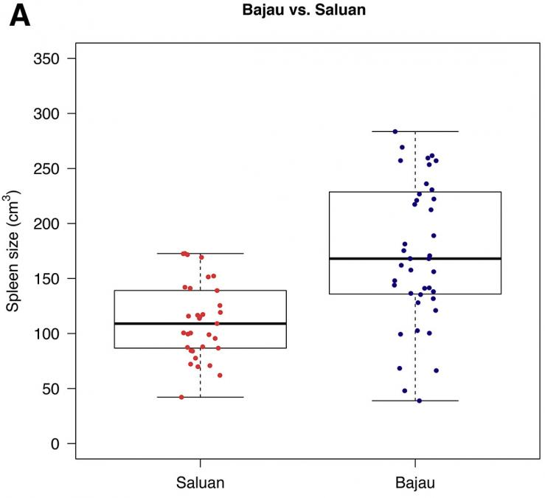
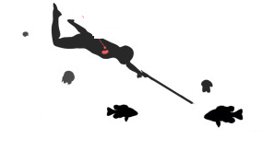

Distributions of spleen sizes in two Southeast Asian human populations: the Saluan and the Bajau (Sea Nomads). The dots on the left and right represent individuals. The thick black horizontal lines inside the boxes indicate the medians. The bottom and top sides of the boxes indicate the 25th and 75th percentiles, respectively.

  - Compare the data points in left to the data points in right. What do you observe about their similarities and/or differences?
  - How do the spleen sizes of the Bajau and the Saluan differ? Use data from the figure to support your response.
  - What statistical tests (hint: chi square, t test, central tendencies, hypothesis testing) might have been used by the scientists to show the difference in populations?
  - Does the figure provide any data that supports the hypothesis that large spleen size is a genetic adaptation? If so, describe that data. If not, what other data would be needed to support this hypothesis?
  - In what other environments might a larger spleen provide a selective advantage to Bajau population?

4a. Describe any two direct gene transfer methods used for animal cells (5 + 5)
4b. Discuss the significance of employing model organisms with examples.
5a. Explain the mechanism of siRNA and any one application of RNAi technology (5 + 5)
5b. Explain any two variants of PCR

6. Answer the following question (5 marks)
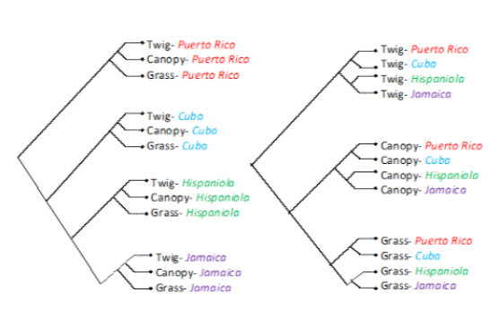
Puerto Rico, Cuba, Jamaica, and Hispaniola have species of anole lizards with distinct body types, including the grass lizards, which have long tails; the canopy lizards, which have large toe pads; and the twig lizards, which have short legs. Anole species with each of these three body types exist on each of the four islands. The phylogenetic trees in the figure below illustrate two hypotheses for how these types of lizards may have evolved.




